Project Report Format
1. PROJECT TITLE
PlantCare AI – AI-Based Plant Disease Detection System Using Deep Learning

2. PROJECT DESCRIPTION
2.1 System Overview:
PlantCare AI is an intelligent web-based application designed to identify plant diseases from images of plant leaves using deep learning techniques. The system allows users to upload a photograph of a plant leaf, which is then processed by an AI model trained to detect patterns associated with different plant diseases. Once the analysis is completed, the system predicts the disease and provides recommendations for treatment and preventive measures.
The system integrates image processing, machine learning, and web technologies to provide a practical solution for early disease detection. By automating the diagnosis process, PlantCare AI aims to support farmers and gardeners in maintaining healthy crops and improving agricultural productivity.

2.2 Problem Domain

Agriculture plays a vital role in food production and the global economy. One of the major challenges faced by farmers is identifying plant diseases at an early stage. Many plant diseases show symptoms on leaves, but farmers may not always have access to agricultural experts who can accurately diagnose these issues.
Traditional methods of disease identification rely on manual inspection and expert knowledge. This approach can be time-consuming and often leads to delayed treatment, resulting in crop damage or loss. The use of artificial intelligence and computer vision offers a modern solution by enabling automated plant disease detection based on visual patterns.

2.3 Core Technology Used

The project uses deep learning techniques to analyze plant leaf images and classify diseases. Transfer learning is used to improve model performance by leveraging pre-trained convolutional neural networks (CNNs).
Technologies used include:
- Python for backend development
- TensorFlow and Keras for machine learning model training and inference
- Flask framework for building the web application backend
- HTML, CSS, and JavaScript for the user interface
- Image processing libraries such as OpenCV and NumPy

2.4 Key Capabilities

The system provides the following features:
- Upload plant leaf images through a web interface
- Automated detection of plant diseases using deep learning
- Prediction of disease type based on trained CNN models
- Display of treatment recommendations for identified diseases
- Easy-to-use interface for farmers and non-technical users

2.5 Target Users
The primary users of the system include:
- Farmers who want quick disease detection for crops
- Home gardeners maintaining plants
- Agricultural researchers studying plant diseases
- Students learning about artificial intelligence in agriculture

2.6 Real-world Relevance
PlantCare AI demonstrates how artificial intelligence can be applied to agriculture to solve real-world problems. By detecting diseases early, the system helps reduce crop loss and supports sustainable farming practices. Such systems can be integrated into smart farming technologies and precision agriculture solutions.

3. APPLICATION SCENARIOS / USE CASES
Agricultural Field Monitoring: Farmers can use the system to identify diseases affecting their crops by simply uploading leaf images. Early diagnosis allows them to apply proper treatments and prevent the spread of disease.
Educational and Research Use: Students and agricultural researchers can use the system to study plant diseases and understand how machine learning models classify visual patterns.
Home Gardening Assistance: Gardeners can diagnose problems in their plants without consulting experts by uploading leaf images and receiving immediate feedback.
Smart Farming Integration: In the future, the system could be integrated with mobile applications or IoT devices to enable automated disease detection in large-scale farming environments.

4. TECHNICAL ARCHITECTURE OVERVIEW

4.1 High-Level Architecture Diagram:
The architecture consists of a frontend interface, a backend server, and a machine learning model that performs disease prediction. The frontend allows users to upload images and view results, while the backend handles processing and communication with the AI model.

4.2 Component Interaction Diagram
The system components interact in the following way:
User → Web Interface → Flask Backend → Image Preprocessing → CNN Model → Prediction → Treatment Recommendation → Result Display

4.3 Data / Request Flow
- The user uploads a plant leaf image using the web interface.
- The image is sent to the backend server for processing.
- The system validates the file format and performs preprocessing steps such as resizing and normalization.
- The processed image is passed to the trained CNN model.
- The model predicts the plant disease based on learned features.
- Treatment information corresponding to the disease is retrieved.
- The final result is displayed to the user.

4.4 System Layers
4.4.1 Frontend Layer
The frontend is responsible for interacting with the user. It provides an interface for image uploads and result visualization.
Technologies used: HTML, CSS, JavaScript.
4.4.2 Backend Layer
The backend processes user requests, performs image preprocessing, and communicates with the machine learning model.
Technology used: Python with Flask framework.
4.4.3 Database Layer
The current system does not use a database. Disease and treatment information are stored locally in structured files or program logic.
4.4.4 External APIs / Services
No external APIs are used in the current implementation.
4.4.5 Deployment Environment
The system is deployed locally during development but can be hosted on cloud platforms in the future.

5. PREREQUISITES
5.1 Software Requirements
- Python 3.x
- Visual Studio Code or Jupyter Notebook
- Flask Web Framework
- TensorFlow and Keras libraries
- Web browser (Chrome or Edge)
5.2 Libraries / Frameworks / Dependencies
The following libraries are required:
- TensorFlow
- Keras
- NumPy
- OpenCV
- Flask
5.3 Hardware Requirements (If Applicable)
- Laptop or desktop computer
- Minimum 8GB RAM recommended
- Internet connection for downloading datasets and libraries

6. PRIOR KNOWLEDGE REQUIRED
To implement this project successfully, the following knowledge areas are helpful:
- Python programming fundamentals
- Machine learning basics
- Deep learning and neural networks
- Convolutional Neural Networks (CNN)
- Image processing techniques
- Web development concepts
Understanding these concepts helps developers build and integrate machine learning models into web applications.

7. PROJECT OBJECTIVES

7.1 Technical Objectives
Develop an AI-based system capable of detecting plant diseases using deep learning algorithms and image processing techniques.

7.2 Performance Objectives
Ensure accurate and fast disease predictions using a transfer learning CNN model optimized for classification tasks.

7.3 Deployment Objectives
Provide a user-friendly web application that allows users to interact with the AI model easily.

7.4 Learning Outcomes
The project aims to demonstrate how machine learning models can be integrated with web applications to solve real-world problems in agriculture.

8. SYSTEM WORKFLOW
The system workflow describes the complete process from user interaction to result delivery.
- The user accesses the web application and uploads a plant leaf image.
- The system validates the uploaded file to ensure it is in the correct format.
- Image preprocessing is performed to prepare the image for model input.
- The processed image is passed to the trained CNN model.
- The model analyzes the image and predicts the plant disease.
- The system retrieves treatment recommendations based on the predicted disease.
- The final results are displayed on the screen for the user

9. MILESTONE 1: REQUIREMENT ANALYSIS & SYSTEM DESIGN

9.1 Problem Definition
Plant diseases significantly affect agricultural productivity. Farmers often struggle to identify diseases accurately without expert assistance. The goal of this project is to develop an AI-based solution that can automatically detect plant diseases using leaf images.

9.2 Functional Requirements
- Upload plant leaf images
- Validate uploaded files
- Detect plant diseases using a trained model
- Display prediction results
- Provide treatment suggestions

9.3 Non-Functional Requirements
- Fast response time
- Reliable predictions
- User-friendly interface
- Secure handling of uploaded files

9.4 System Design Decisions
Transfer learning was chosen to improve model accuracy while reducing training time. Flask was selected for backend development due to its simplicity and flexibility.

9.5 Technology Stack Selection
Python and TensorFlow provide strong support for deep learning and model deployment, making them suitable for this project.

10. MILESTONE 2: ENVIRONMENT SETUP & INITIAL CONFIGURATION

10.1 Development Environment Setup
The development environment includes Python, required machine learning libraries, and an IDE such as Visual Studio Code.

10.2 Dependency Installation
Dependencies are installed using pip.
Example command:
- pip install tensorflow keras flask numpy opencv-python

10.3 Project Structure Creation
The project folders are organized to separate frontend files, backend logic, and machine learning models.

10.4 Configuration Setup
Configuration settings include model paths, dataset paths, and application parameters defined in the backend code.

11. MILESTONE 3: CORE SYSTEM DEVELOPMENT

Feature 1 – Image Upload
The system provides an interface that allows users to upload plant leaf images. The uploaded images are sent to the backend server for processing.

Feature 2 – Disease Prediction
The backend processes the uploaded image and sends it to the trained CNN model. The model analyzes visual patterns in the leaf and predicts the disease category.

Feature 3 – Result Display
The system displays the predicted disease name along with treatment recommendations and relevant information.

12. MILESTONE 4: INTEGRATION & OPTIMIZATION
The frontend interface, backend server, and machine learning model are integrated into a single workflow. Performance optimization techniques such as efficient image preprocessing and optimized model inference are applied to ensure faster predictions.
Input validation and error handling mechanisms are implemented to prevent invalid file uploads and improve system reliability.
13. MILESTONE 5: TESTING & VALIDATION
13.1 Test Cases
Test Case ID | Input | Expected output | Status
TC1 | Upload valid leaf image | Disease prediction displayed | Pass
TC2 | Upload invalid file | Error message displayed | Pass
TC3 | Upload healthy leaf | Healthy classification | Pass
TC4 | Upload infected leaf | Disease detected | Pass

13.2 Performance Metrics
For evaluating the machine learning model, the following metrics are considered:
- Accuracy : 0.9655172413793104
- Precision: 1.0
- Recall : 0.9655172413793104
- F1 Score : 0.9793103448275862

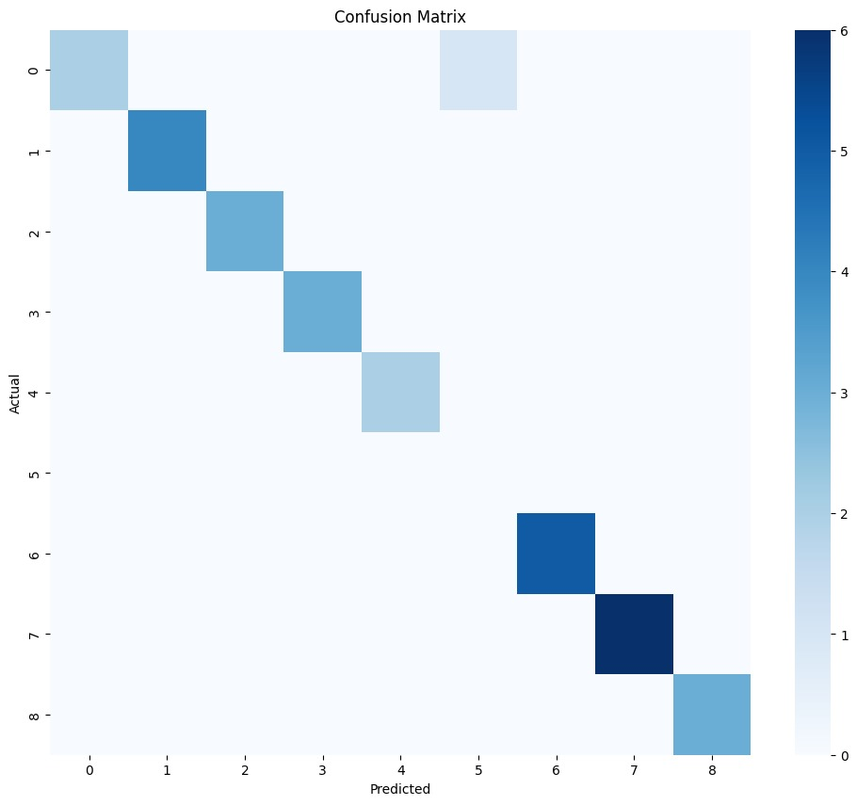

14. DEPLOYMENT

14.1 Deployment Architecture
The PlantCare AI system is currently deployed in a local development environment. The web application runs on a local server using the Flask framework, which handles user requests and communicates with the machine learning model.
Users interact with the system through a web browser. The uploaded plant leaf image is processed by the backend server, which sends it to the trained CNN model for prediction. The predicted disease and treatment suggestions are then returned to the user interface.
Architecture Flow:
User Browser → Flask Web Server → Image Processing Module → CNN Model → Prediction Result → Result Display

14.2 Hosting Platform
The application is currently hosted on a local development server using Python and Flask.
The system runs on a local machine and can be accessed through a web browser via the local server address.
Example:
  - http://localhost:5000

Deployment Steps
- Install required dependencies using pip.
- pip install tensorflow keras flask numpy opencv-python
- Ensure the trained CNN model file is placed in the project directory.
- Run the Flask application.
- python app.py
- Open a web browser and access the application through the local server address.
- Upload a plant leaf image to receive disease predictions.

14.4 Production Considerations
For production deployment, several improvements would be required:
- Deploy the system on a cloud hosting platform.
- Implement secure file upload mechanisms.
- Use a database for storing disease and treatment information.
- Improve system scalability for multiple users.
- Optimize model inference speed.

15. PROJECT STRUCTURE
PlantCare-AI/
├── data/
├── docs/
├── models/
├── notebooks/
├── src/
├── static/uploads/
├── templates/
├── README.md
├── .gitignore
└── requirements.txt

data/
This folder contains the dataset used for training the plant disease detection model. It includes images of plant leaves categorized into different disease classes.

docs/
The docs folder contains project documentation files such as diagrams, reports, or design documents related to the development of the system.

models/
This folder stores the trained machine learning models used for plant disease prediction. The trained CNN model is loaded from this directory when the application runs.

notebooks/
The notebooks folder contains Jupyter notebooks used for experimentation, model training, dataset preprocessing, and evaluation during the development phase.

src/
The src directory contains the main backend source code of the application. It includes the logic for handling user requests, image preprocessing, and interaction with the trained machine learning model.

static/uploads/
This folder stores images uploaded by users through the web interface. Uploaded plant leaf images are temporarily saved here before being processed by the system.

templates/
The templates folder contains HTML files used for the frontend interface of the web application. These templates are rendered by the Flask backend to display the user interface.

README.md
The README file provides an overview of the project, installation instructions, and usage guidelines for running the application.

.gitignore
This file specifies files and folders that should not be tracked by Git, such as temporary files, cache files, and environment configurations.

requirements.txt
This file lists all Python libraries required to run the project. These dependencies can be installed using the pip package manager.

16. RESULTS

16.1 Disease Detection Performance
The trained convolutional neural network (CNN) model analyzes plant leaf images and predicts the most probable disease class based on visual patterns learned during training. The model demonstrates reliable performance for identifying different plant diseases included in the dataset.
During testing, the model was able to correctly classify plant diseases for most uploaded images. The predictions were generated within a few seconds after uploading the image, providing a fast and user-friendly experience.

16.2 Prediction Output
When a user uploads a plant leaf image, the system processes the image and returns the following information:
- Predicted disease name
- Confidence score or prediction probability
- Suggested treatment or corrective measures
The result is displayed on the web interface so that the user can easily understand the diagnosis.

16.3 System Interface Results
The web application successfully allows users to upload plant leaf images and view prediction results. The interface is simple and easy to use, making it suitable for farmers and non-technical users.

Example Prediction Results
Example scenarios tested during system evaluation include:
- Healthy leaf images were correctly classified as healthy.
- Diseased leaves such as tomato leaf diseases were identified with correct labels.
- The system rejected invalid image formats and displayed error messages.
16.4 Screenshots of Results
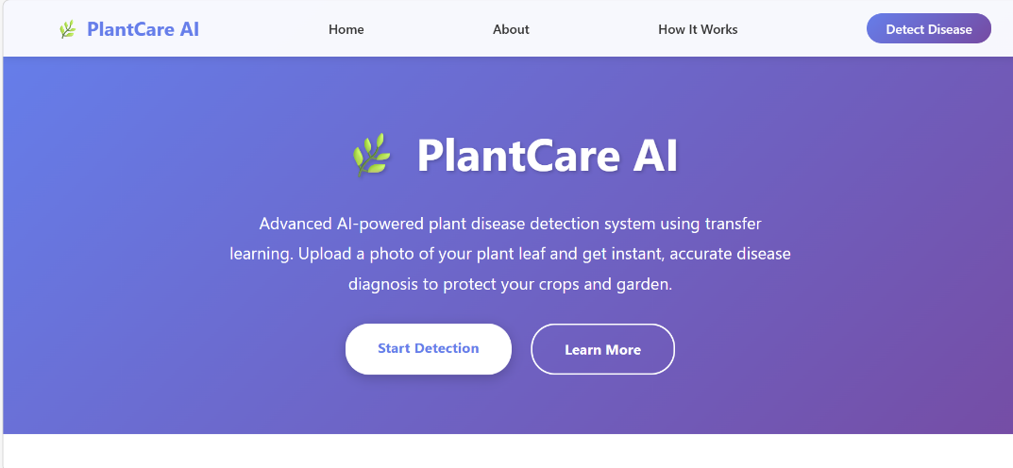
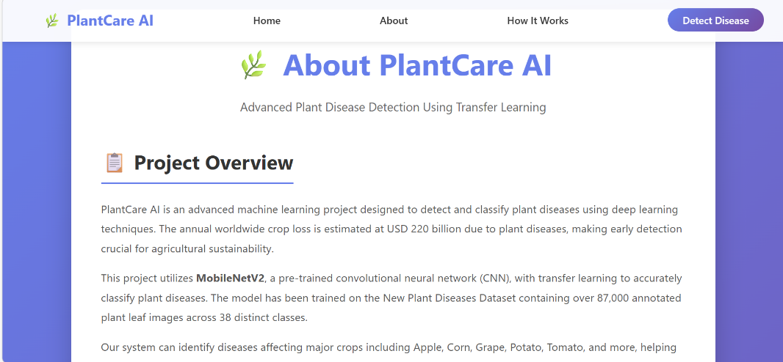
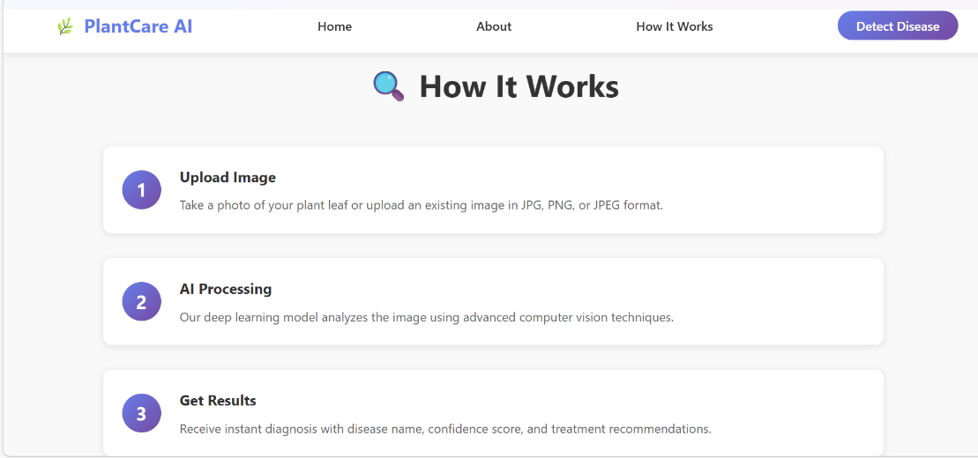
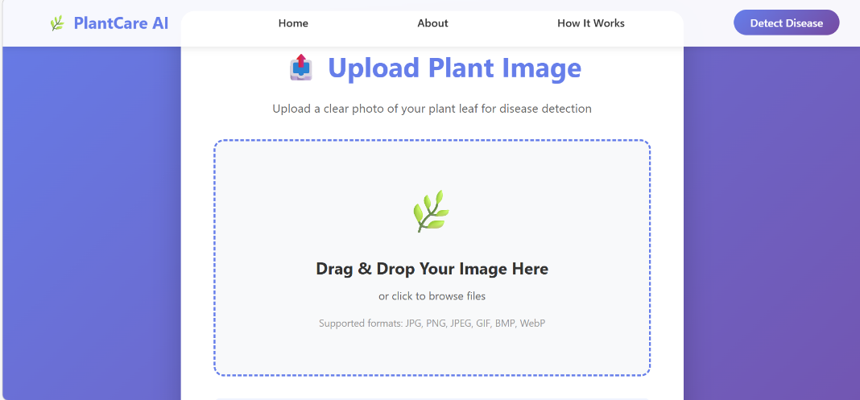
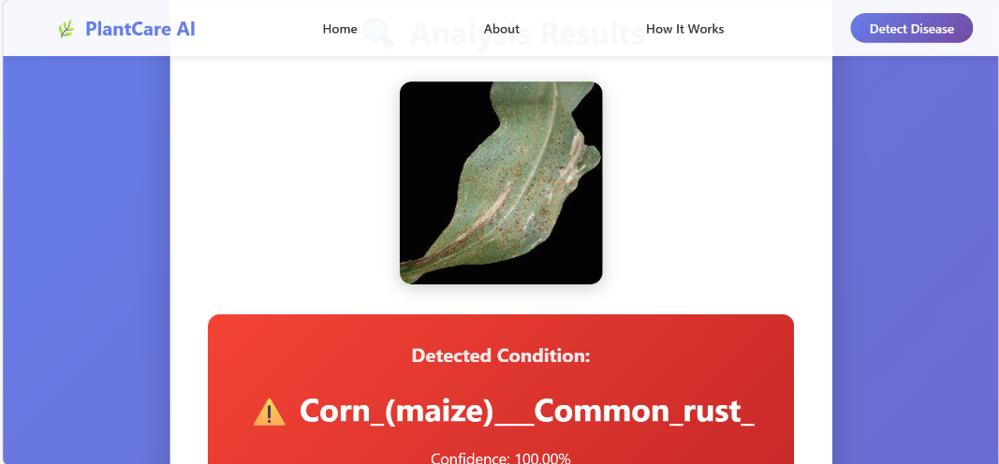

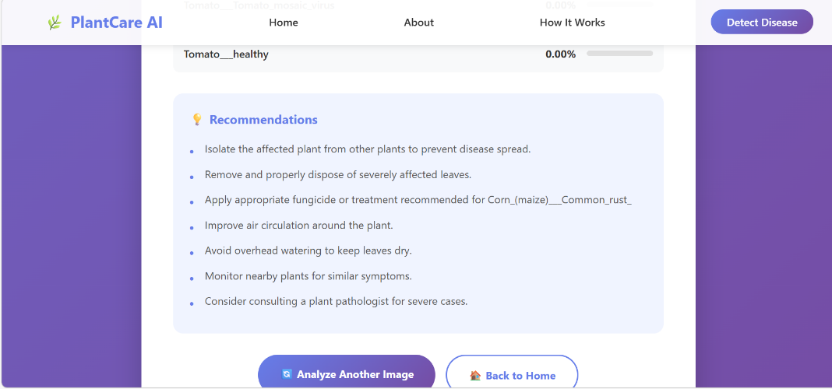

17. ADVANTAGES & LIMITATIONS
● Advantages
Early Disease Detection
The system enables early identification of plant diseases by analyzing leaf images. Early detection helps farmers take preventive measures before the disease spreads further.
Automated Diagnosis
Traditional disease identification requires expert knowledge. This system automates the process using artificial intelligence, making it accessible to farmers and gardeners without specialized training.
User-Friendly Interface
The web-based interface is simple and easy to use. Users only need to upload an image of a plant leaf to receive predictions and treatment suggestions.
● Limitations
Dependence on Image Quality
The prediction accuracy may be affected if the uploaded image is blurred, poorly lit, or contains multiple leaves.
Limited Disease Classes
The system can only detect diseases that are included in the training dataset. Diseases not present in the dataset may not be recognized.
No Mobile Application
Currently, the system is implemented as a web application and does not include a dedicated mobile application.

18. FUTURE ENHANCEMENTS
- Mobile Application Development
A mobile application could be developed to allow farmers to capture plant leaf images directly using their smartphones and receive instant predictions.
- Cloud Deployment
Deploying the system on cloud platforms such as AWS, Google Cloud, or Azure would allow the application to be accessed by users from different locations.
- Support for More Plant Diseases
The dataset can be expanded to include additional plant species and diseases, improving the model's accuracy and coverage.
- Real-Time Monitoring
Integration with IoT devices or smart farming systems could enable real-time monitoring of crop health.

19. CONCLUSION
PlantCare AI demonstrates how artificial intelligence and deep learning can be applied to solve real-world agricultural problems. The system successfully integrates machine learning with a web-based interface to detect plant diseases from leaf images.
By using a trained convolutional neural network model, the system can analyze plant leaf images and predict diseases with good accuracy. The web application allows users to easily upload images and receive predictions along with treatment suggestions.
This project highlights the potential of AI-driven solutions in agriculture, particularly for improving crop management and reducing losses caused by plant diseases. With further improvements such as cloud deployment and mobile application development, the system could become a valuable tool for farmers and agricultural professionals.

20. APPENDIX

20.1 Source Code
The complete source code of the project is available in the GitHub repository.
20.2 GitHub Repository:
- https://github.com/Khushitomar14205/PlantCare-AI
20.3 Dataset Information
The dataset used for training the model contains plant leaf images categorized into different disease classes. The dataset was used to train and evaluate the CNN model for disease classification.
20.4 Model Training Details
The deep learning model was trained using transfer learning techniques to improve accuracy and reduce training time. Pre-trained CNN architectures were adapted to classify plant disease images.
20.5 Demonstration
The working application allows users to upload plant leaf images and receive disease predictions through the web interface.

